Appendix 2 - Consultation Process and Events

1. Consultation process
The consultation went live on 17th October 2014, when it was made available on the Council’s website home page. The consultation close date was extended by one week to 24th December 2014.

Invitations were sent via the eConsult portal to the 499 people and organisations that were invited to take part in consultation for the current Culture Strategy 2012–15.

The url to the eConsult portal was also sent to 30 people and organisations that are part of the Youth Engagement Officer’s network. In addition the Culture Manager requested that her staff provide the url to their respective networks.

2. About the respondents.
In addition to extensive discussion with interested parties – all broadly supportive of the strategy - 13 formal responses were submitted – 12 online and one via email. The email response is added at the bottom of this report.

The respondents are from the following organisations: Arts Council England; 13th Theatre Co; Cowley Road Works; Folk Arts Oxford; University of Oxford, Dept of Education; Oxford Castle Ltd; Wesley Memorial Methodist Church; Innovista International; The Story Museum; Justice in Motion; and Oxford Preservation Trust.

3. Responses in the eConsult system.
The survey questions and responses are presented below. The survey questions were aligned to the three priorities set out in the draft Culture Strategy. Given the nature to the responses, it seemed helpful to present the comments verbatim.

Priority One: To support the sustainability of Oxford’s cultural organisations and improve the skills and diversity of the city’s current and future creative workforce.

Question 1 and comments.

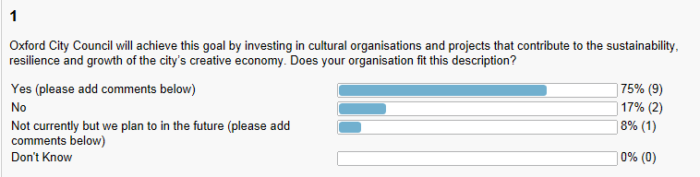

13th Theatre Company. We are a social enterprise theatre company. We deal with social issues of disability, bullying and self-esteem. Our motto is why fit the mould when you can create it. We are a equal opportunities company and socially inclusive. We also run drama workshops for people 50+ called Never Past the Sell by
Wilson (Freelance). As a freelance theatre/dance artist I am a small part of Oxford's creative economy, but represent a significant proportion of frontline individuals who initiate and deliver cultural projects.
Oxford Methodists. We currently offer space to cultural events, and would like to increase this. We also plan to develop a heritage interpretation centre, drawing out Oxford's part in the story of the worldwide Methodist movement.
Oxford Castle Quarter is a cultural hub within Oxford. With an art gallery, visitor attraction, museum and education centre it offers a variety of cultural and educational experiences to a diverse audience.
The Story Museum. After completion of our capital development The Story Museum will employ 27 people to run a six-day a week venue programming original creative content and be largely self-supporting through ticket income and associated sales. Since opening in April we are attracting visitors from outside Oxfordshire
Arts Council England. Co-investment between ACE and Oxford City Council is essential to the sustainability of the city's creative economy. The Council's ongoing investment in culture is hugely significant to leveraging funding from ACE and other sources, at all levels.
Cowley Road Works. Cowley Road Carnival provides opportunities for established, new, emerging, young and diverse artists and organisations to perform/exhibit/engage/showcase their work to a large and diverse audience, and to work in partnership with Cowley Road Works on pre Carnival events and activities.

Justice in Motion is a multidisciplinary company, which is dedicated to creating issue-based work, inspired by true accounts of social injustice. Through a dynamic fusion of physical theatre, dance, music, multi-media and spoken word, the company presents a variety of engaging and thought-provoking performances. Our ambition is to operate as a creative ambassador that will impact our culture and society - calling forth change and transformation towards a life of freedom and justice.

As a young and developing company, one of our goals is to secure our reputation within the Oxfordshire theatre and dance community. As such we create high quality performances and host dance classes for professionals (weekly), workshops and events – all of which contribute to the city’s creative economy. When employing performers, artists, and teachers we strive to pay them a competitive fee, which will encourage and facilitate their continued work in our area. We regularly hire and pay venues for rehearsals or performance. The larger we grow, the more productive we are, and the more we can and do contribute to Oxfordshire’s creative economy.

Question 2 and comments.

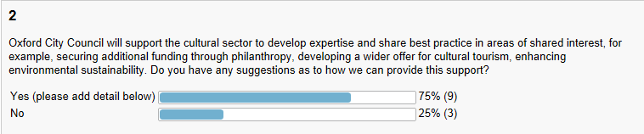

13th Theatre Company. We give a percentage of our profits to charity, we are working in partnership with the TVACAA. We are also producing a musical called Hooked on Oxford, the musical, it is created to attract tourism to Oxford.
Wilson (Freelance). Addressing the needs of the large proportion of freelance artists (across all disciplines - music, theatre, dance, visual arts). To do this free (or heavily subsidised) training/up-skilling is needed in these areas.
Oxford Methodists. Networking opportunities for those already involved, with scope to share best practice.
Oxford University. Advice and support and other "help in kind"
Oxford Castle Quarter. The HLF workshop at the Museum of Oxford was extremely useful. The cultural organisations across Oxford each have their own area of expertise and individuals with specific skill sets. Further integrated workshops would be helpful. A more comprehensive strategy for data sharing would also be useful.
The Story Museum. Offering grants as matched funding is helpful as well as supporting city-wide collaborative events such as Alice's Day and Christmas Light Festival. Promotion of the city's cultural offer to both tourists and residents is also very valuable.
Arts Council England. The Oxford Cultural Partnership should continue to act as the key strategic partnership for culture in Oxfordshire over 2015-18 and become even more focussed on how the sector can work together to seize joint opportunities e.g. shared audience development or cultural tourism initiatives.
Cowley Road Works. Improve OCC's Streetscene's ability to effectively collect and recycle waste at outdoor events. Provide more and affordable banner and poster sites across the city to enable publicity for events of all kinds. The costs of current provision & commercial distribution are out of reach of many.
Justice in Motion. At this point we do not have suggestions for how the Council can further provide this support. For our purposes the city has been extremely helpful in helping us find funding.

Question 3 and comments.

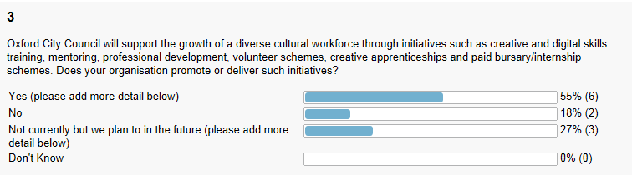

Folk Weekend. Oxford offers volunteer on the job training in various arts management roles, as well as providing general volunteering opportunities during the festival.
Oxford Methodists. We use volunteers to support our existing programmes, and deploy and develop staff to enhance what we are able to do.
Oxford Castle Quarter. O3 Gallery provide volunteer and internship schemes. Oxford Castle Quarter plan to introduce volunteer schemes in 2015.
The Story Museum. employs 6 full-time equivalent staff, several freelance experts, and c100 volunteers donating 60-300 hours a week. We provide work experience placements for 12 local secondary school children and around 8 intern placements for college leavers annually.
Arts Council England. NPOs/MPMs produce diversity action plans and data will be collected annually. The Creative Employment Programme is open till Nov ' 15. ACE is committed to fair payment for artists. Grants for the arts continues to thrive and we are keen to support first-time and diverse applicants.
Cowley Road Works. Yes, we work with volunteers & can offer practical professional development. The time & cost of supporting apprentices and providing effective mentoring must be recognised. All of this requires additional financial support. Specific training for mentors & digital skills would be helpful.

Justice in Motion We are looking into providing a paid internship scheme within our company. We are currently in the process of identifying and sourcing payment via grant proposals for this. If there is any financial support from the city for these schemes, we would happy to learn more about that.

Question 4 and comments.

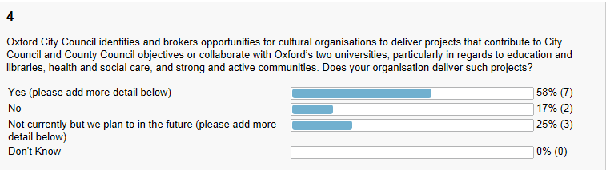

Wilson (Freelance). I have in the past been involved in these activities.
Folk Weekend. We work in partnership with Oxford Brookes providing work experience for their sound technician students
Oxford Methodists. We are already committed to strong and active communities, and support this through our own activities and through provision of space to other groups.
Oxford University. It would be useful if the strategy could recognise the funding now provided by the University of Oxford for such things as the Cowley Road Carnival and Alice's Day.
Oxford Castle Quarter are working with Oxford University to deliver projects in 2016 with regards to education, outreach, and strong and active communities.
The Story Museum. We enrich children's lives through story with associated benefits in literacy levels. We frequently work in partnership with organisations such as the University Museums, the Bodleian library and the central library. We also co-create new work to deepen young people's involvement with culture.
Arts Council England. We are in discussions with Oxfordshire LEP towards a 'creative and cultural investment plan' and with the University of Oxford about co-investment in culture. We want to influence high level strategic partnerships and funding opportunities for culture in Oxford through various means.
Cowley Road Works. We have worked with students from both universities and seek to do more with them. We work with community groups & would welcome further opportunities to help build strong & active communities.

Justice in Motion We certainly aim to work closely with the health and social sector of Oxford and are very keen on forming relationships to both Universities in that respect too. We are interested in forming stronger connections with researchers and experts from both Brooks and Oxford University. To date, we had several collaborations and will deepen those as well as identifying further ones down the line. Artistic director Anja Meinhardt also works closely with the Oxford University Drama Society and has been involved in several University productions, which allowed her to from valuable links.

Whilst we do not currently collaborate with Oxford’s two universities as such, we do perhaps contribute to the City and County Council objectives as related to the cultural economy. We are not sure however if these objectives are the same as the priorities outlined in this document.

Priority Two. To improve opportunities for Oxford’s diverse range of communities to actively engage with and be inspired by culture.

Question 5 and comments.

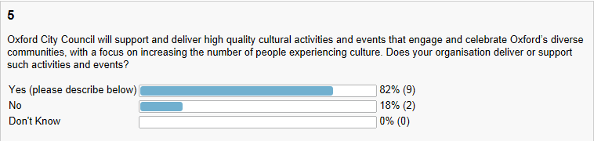

13th Theatre Company. We fully support such activities and will gladly become a part of them.
Wilson (Freelance). As a freelance performer I have performed in & produced a variety of high-quality cultural events, in partnership with other organisations.
Folk Weekend runs a ceilidh for children with Special Needs - in 2015 we hope to run two, and are also in the early stages of a project combining Makaton signing with performance.
Oxford Methodists. We provide space for a wide variety of groups and individuals.
Oxford Castle Quarter
2015: Oxford Art Prize
2016: Fields of Battle - Centenary project
The Story Museum. We offer workshops, creative activities, performances, skills building, holiday courses and resources for all ages. We anticipate reaching 20,000 people in the first year of opening (April 14- April 15) plus over 5,000 school children and teachers including targeted schools from disadvantaged areas
Arts Council England. NPOs/MPMs will have audience development plans in place for 2015-18. We recognise the importance of large-scale, community events e.g. Christmas Light Night, Alice's Day and welcome conversations with OCC and partners about plans for 2015-18.
Cowley Road Works. Cowley Road Carnival specifically seeks to address this priority, with 45,000 people of all ages and social and ethnic backgrounds attending Carnival 2014.
Justice in Motion is proud to work a little differently than other Oxfordshire theatre and dance companies. Our work is specifically aimed at issues of social injustice and as such our target audience engages community activists, policy changers and their constituents, and people who may be vulnerable within our society. In engaging these communities we are actively bringing a new audience into the creative fold, building a bridge between the arts and campaigns.
We currently deliver a series of events about socially relevant issues, and facilitate workshops in the genres that influence the style of our work, supported by the Oxford City’s Culture Fund. These events and workshops are open to the wider public.

Question 6 and comments.

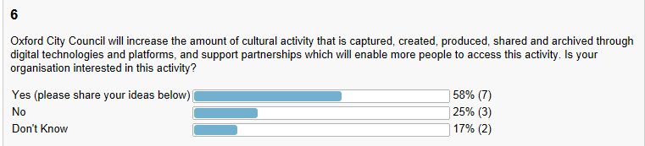

Wilson (Freelance). At present I do not have the capacity to deliver digital projects. Though many freelancers may well be interested n this area.
Oxford Methodists. We plan to develop our existing website to support heritage interpretation and to enable virtual tours.
Oxford University. Could provide partnerships with the University
Oxford Castle Quarter. We are working with Oxford University ITC department and Europeana. We're very pleased to see this is part of Oxford City Council's Cultural Strategy.
The Story Museum is currently planning an exhibition for 2015 in partnership with local digital games companies including Natural Motion, Sega and Rebellion. This will enable us to build new audiences and pilot innovative ways of using digital technologies in our building for the future.
Arts Council England. Oxford is a dynamic hub for the creative industries. We encourage the cultural sector (and this strategy) to position themselves strongly within Oxford's creative economy as a whole and to make the most of new kinds of collaboration and digital approaches to achieving strategic aims.
Cowley Road Works. The output of Carnival is particularly strong visually and we are very interested in harnessing the many images and films which are created by the public during the event to share these. Carnival provides opportunities to show case musicians at the event & digitally before & after the event.

Justice in Motion is a multidisciplinary company and as such we work with many artists across many fields. We work with several filmmakers to document our work through a series of short trailers and documentaries, as well create visual projections that are combined with our live performances. We are currently looking at creating another three short trailers that will capture the research and re-development phase for BOUND, while getting ready for our 2015 national tour.

Question 7 and comments.

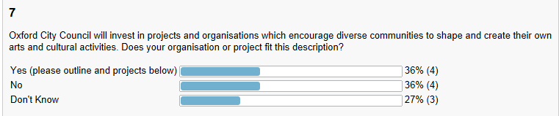

13th Theatre Company. Yes, we encourage social inculsion and we are an equal opportunities theatre company. Our aim is to use drams to break down the barriers caused by discrimination.
The Story Museum. We are running a pilot project with a group of local teenagers programming a season of events aimed at their peers. Our next major exhibition (summer 2015) will involve a substantial co-curation element and we are holding an access day in January to involve and consult with those with specific needs
Arts Council England. Good practice in Oxford e.g. Old Fire Station, Story Museum, Pegasus, Museum of Oxford and further afield e.g. ACE-funded Creative People and Places projects. Our Engagement & Audiences team can advise further. Libraries should be key partners and our Libraries GFTA fund continues.
Cowley Road Works. Cowley Road Carnival invites diverse communities to show & celebrate their identities through participation in the procession, through food, music, dance and other activity, both at the event and in the lead up to it.

Priority Three. To improve opportunities for young people to access and actively participate in cultural activities.

Question 8 and comments.

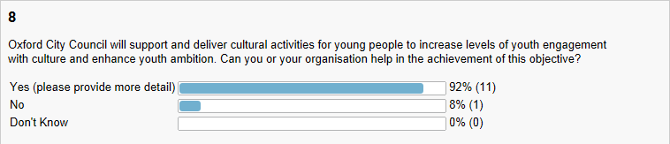

Dr Hafiz We can circulate it among young people within BME communities.
Wilson (Freelance). I also work as a lecturer in a UK drama school and have experience in mentoring and training young artists (18-25) inside and outside of my institution.
Folk Weekend. has always held a series of concerts featuring young performers - we have just engaged a new committee member who is planning on expanding this area for 2015. We also run a programme of family events during the festival.
Oxford Methodists. Several of our young people are already engaged with film and music at a high level.
Innovista. We work with disengaged and hard to reach young people, to increase ambition, aspiration and achievement. We'd be very open to exploring how cultural activities could help us do this.
Oxford University. We are looking in to the provision of college and other university space for the communities of Oxford.
Oxford Castle Quarter. The Key Learning Centre within Oxford Castle Quarter is an ideal environment for these activities and we'd be very keen to work with Oxford City Council in developing an outreach programme.
The Story Museum. As well as co-curation projects at the Museum we run outreach projects in schools and community groups. We are in active discussions with the local library service to run a project with young people celebrating the Magna Carta in 2015 and with the Bodleian Library to celebrate Shakespeare 2016
Arts Council England. Work with young people is a strength in Oxfordshire. We are promoting 7 'quality principles' for CYP work at this time. Artswork continues as the Bridge organisation for the South East over 2015-18 – a key partner. We are positive about the development of the Oxfordshire Youth Arts Network.
Cowley Road Works. The Carnival procession & preceding workshops led by artists & dancers in schools gives hundreds of children the opportunity to take part with confidence & pride in their work. The established youth music stage at Carnival offers young musicians a profile & audience which they really appreciate.

Question 9 and comments.

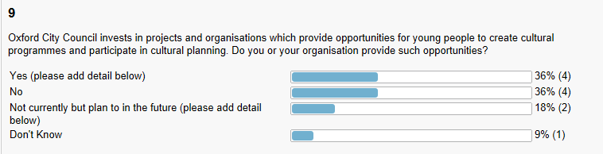

13th Theatre Company. Young people need support and encouragement and that is an aim of our company to help young people achieve their goals.
Oxford Methodists. See question 8 above.
The Story Museum. We plan to build on our pilot teenage co-curation project for future programming, as well as establishing a young curators group to provide regular input into the Museum's programming
Arts Council England. is funding good models for youth-led cultural planning and participation in Oxford e.g. Pegasus, Oxford Playhouse, University Museums, and further afield e.g. the Art31 Youth Arts programme in Kent. Bicester also aims to develop a youth-led cultural plan.
Cowley Road Works. We would very much like more young people to be involved in the planning of Carnival & seek ways to do this. We work with key partners, Pegasus and Fusion Arts, who are specialists in working with young people. We seek young trustees.
Justice in Motion. We are anticipating working with a younger community as well, and our workshops are open to people from age 14+.
We are likely to be going into schools as well to deliver workshops and meet them where they’re at, inviting them too to engage in the debate about relevant issues. We do see the possibility of reaching out into schools in conjunction with OXCAT (Oxfordshire Community against Trafficking) for example, who are planning on educating young people in more creative ways

Question 10 and comments.

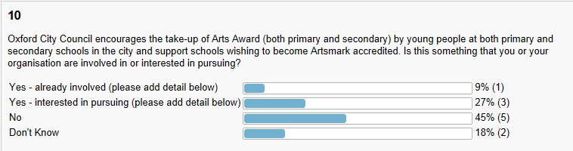

13th Theatre Company. Yes, we would gladly be involved in this project, please consider us for this project.
Folk Weekend. We have someone who is trained in Arts Award but don't really know how to persue this as a fairly small, voluntary organisation.
The Story Museum. Our Head of Learning is trained to deliver Arts Award. We made 7 Discover awards through our Digital Storytelling course in the summer and plan to deliver Bronze awards through our teen co-creation project in Spring 2015.
Arts Council England. Arts Award and Artsmark are funded by Arts Council England and a key strategy for increasing youth participation in arts and culture. NPOs/MPMs have objectives related to Arts Award & Artsmark. Artswork as the Bridge organisation can support organsations working with these schemes.
Cowley Road Works. Through partner organisations such as Pegasus, Fusion and OYAP.

Any other comments?

Wilson (Freelance). Key to delivery at ground level will be supporting the range of freelance artists who often undertake this work. Ways to address the development of these artists, in response to their needs, will be key in extending and consolidating current practice.
Oxford University. In all of these priorities the University would be interested in developing advice/support/joint working.
The Story Museum's mission to inspire learning and improve well-being through story, especially for the young and those facing disadvantage, puts us in an ideal position to deliver on all 3 priorities, plus our use of volunteers means that we offer many opportunities for skills development
Arts Council England. 2015-18 ACE Strategic funds (TBA) may offer opportunities for joint approaches from Oxford and Oxfordshire. Over 2015-18 ACE wants to see – and to be part of – highly collaborative approaches to tackling some of the ongoing opportunities/challenges for the culture sector in Oxford.
Justice in Motion. It seems that as a company, JUSTICE IN MOTION, best suits priorities one and two. As we grow in reputation and productivity, we are keen to engage and work with more artists helping to grow Oxford’s creative economy. We have been thankful for the city’s support we’ve received so far and are proud to say we’ve only grown more and more since. We are happy to be engaged and active in the city’s support of its creative sector and will help out however we can!

5. Responses via email.

Giles Ingram, Experience Oxfordshire

I thought you may be interested in headline stats from a new VisitBritain survey of international visitors – ‘Leveraging our Heritage & Culture’. 53% of respondents state culture and heritage as their main motive for visiting Britain.

Response from Oxford Preservation Trust
Oxford Preservation Trust is pleased to comment on Oxford City Council’s Draft Culture Strategy 2015-18 and have completed the on-line questionnaire. We would however like to take the opportunity to make the following points.

We welcome Oxford City Council’s vision for culture and the arts and its 3 key priorities for culture and are in accord with the vision which will be “delivered through partnership working high quality cultural experiences, and a commitment to accessibility.”

However we are concerned that there are some key gaps and omissions within the delivery mechanisms which could impact on the quality of the cultural experiences and the overall success and sustainability of the strategy. In addition we are concerned that these omissions may also have a negative impact on the success and sustainability of OPT’s own core activities and projects going forward.

Partnership
Given the importance of partnerships to the delivery of the strategy we are extremely concerned to note that Oxford Preservation Trust have not been recognised as a key Cultural Partner and that our projects and Oxford Open Doors in particular is not identified as a major potential vehicle for delivering the strategy nor referenced within any of the case studies – especially the sections on Cultural Tourism and Cultural Events.

Oxford Preservation Trust has an extensive track-record in delivering cultural partnership projects including; as a key partner in the redevelopment of Oxford Castle; as creator and organiser of Oxford Open Doors as well as project partner and supporter for many national and individual projects including Portrait of a Nation ‘Car to Spire’ (Oxford Centre of Culture 2009) for Discovering Places (Engaging places /Cultural Olympiad 2010-12).
Working in partnership with Oxford University since 2008 we have created the largest Heritage Open Days festival in the country attracting c22, 500 visitors in 2014 the majority of whom were local. The cultural event is recognised for providing a broad showcase for many if not most of the city’s cultural partners who open their doors alongside community faith and businesses to engage with local people and provide access to a cross-section of the city’s tangible and intangible treasures alongside contemporary art, architecture and performance. We work already with both universities on this ‘Festival of Oxford’ and have had considerable support from the County Council. It would be a major missed opportunity not to endorse and use this city-wide community festival as an important showcase for Oxford’s culture and as a vehicle for community engagement. We have had several recent discussions with the City Council about support for Open Doors both financial and in terms of policy and we have raised our concerns that the continued lack of perceived city support will impact on our ability to leverage funds and sustain confidence from potential backers going forward.

We are also disappointed to note that there is limited mention of Oxford Castle (Oxford Castle Quarter, Oxford Castle Unlocked and the O3 Gallery) within the strategy. The Castle has been part of a consistent city cultural offer since the site was redeveloped in 2006 (Ghost Fest, Folk Festival, Dancin Oxford, Theatre Performances, Cinema, Medieval Fair, Britain/Earth from the Air). The redevelopment of the castle has also most importantly created new public space for the city while unlocking the origins of the town story that it contains providing balance and much needed links to the more familiar University story. We have been increasingly concerned that the historic connection between the site and the County Council has meant that the castle is seen as more of a county concern and has not been fully embraced by the city to the detriment of the Castle Quarter and for those for whom Oxford is their city or county town regardless of administrative boundaries.

Building a world class cultural offer for everyone
We welcome the City Council’s commitment to building a world class cultural offer for everyone but would wish to see the Cultural Strategy make full reference to the importance and scale of Oxford’s rich heritage as a resource for achieving this. Oxford Preservation Trust has been working on a Heritage Plan Framework for the city in partnership with Oxford City Council funded by English Heritage. Oxford City Council, Oxford Preservation Trust and English Heritage “believe that Oxford's heritage is more than just a tourist attraction; it is an important resource that adds to the quality of our lives in many ways, providing an attractive environment, generating tourism, a catalyst for regeneration and stability in times of change” (Oxford City Council Website) . We believe that by understanding more about the history and the development of the city and sharing what they value within it local people will feel a sense of community and belonging and be more connected to their city.

We are also concerned by the definition of arts and culture in the Strategy and the place of heritage within this. It is important that Oxford’s cultural heritage is not seen as belonging only to the University and tourists at the expense of local people and the important ‘town’ story or that contemporary arts are positioned against the city’s rich cultural heritage whether that of the University or of the motor industry, May Morning and Cowley Road Carnival. We are keen that the strategy should draw on the widest resource for the cultural offer and provide a full range of opportunities for it to inspire and feed into creative activity and industries.

The Cultural Strategy demonstrates the huge amount that the city council has achieved to date and we are keen to discuss ways going forward how Oxford Preservation Trust can join up with the city in this endeavour as a proper Cultural Partner.

Appendix 3
Initial Equalities Impact Assessment screening form

Prior to making the decision, the Council’s decision makers considered the following: guide to decision making under the Equality Act 2010:

The Council is a public authority. All public authorities when exercising public functions are caught by the Equality Act 2010 which became law in December 2011. In making any decisions and proposals, the Council - specifically members and officers - are required to have due regard to the 9 protected characteristics defined under the Act. These protected characteristics are: age, disability, race, gender reassignment, pregnancy and maternity, religion or belief, sex, sexual orientation and marriage & civil partnership

The decision maker(s) must specifically consider those protected by the above characteristics:
(a) To seek to ensure equality of treatment towards service users and employees;
(b) To identify the potential impact of the proposal or decision upon them.

The Council will also ask that officers specifically consider whether:
- The policy, strategy or spending decisions could have an impact on safeguarding and / or the welfare of children and vulnerable adults
- The proposed policy / service is likely to have any significant impact on mental wellbeing / community resilience (staff or residents)

If the Council fails to give ‘due regard’, the Council is likely to face a Court challenge. This will either be through a judicial review of its decision making, the decision may be quashed and/or returned for it to have to be made again, which can be costly and time-consuming diversion for the Council. When considering ‘due regard’, decision makers must consider the following principles:

- The decision maker is responsible for identifying whether there is an issue and discharging it. The threshold for one of the duties to be triggered is low and will be triggered where there is any issue which needs at least to be addressed.
- The duties arise before the decision or proposal is made, and not after and are ongoing. They require advance consideration by the policy decision maker with conscientiousness, rigour and an open mind. The duty is similar to an open consultation process.
- The decision maker must be aware of the needs of the duty.
- The impact of the proposal or decision must be properly understood first. The amount of regard due will depend on the individual circumstances of each case. The greater the potential impact, the greater the regard.
- Get your facts straight first! There will be no due regard at all if the decision maker or those advising it make a fundamental error of fact (e.g. because of failing to properly inform yourself about the impact of a particular decision).
- What does ‘due regard’ entail?
  - Collection and consideration of data and information;
  - Ensuring data is sufficient to assess the decision/any potential discrimination/ensure equality of opportunity;
  - Proper appreciation of the extent, nature and duration of the proposal or decision.
- Responsibility for discharging can’t be delegated or sub-contracted (although an equality impact assessment (“EIA”) can be undertaken by officers, decision makers must be sufficiently aware of the outcome).
- Document the process of having due regard! Keep records and make it transparent! If in any doubt carry out an equality impact assessment (“EIA”), to test whether a policy will impact differentially or not. Evidentially an EIA will be the best way of defending a legal challenge. See hyperlink for the questions you should consider http://occweb/files/seealsodocs/93561/Equalities%20-%20Initial%20Equality%20Impact%20Assessment%20screening%20template.doc

- Within the aims and objectives of the policy or strategy which group (s) of people has been identified as being potentially disadvantaged by your proposals? What are the equality impacts?

The Council’s has three key priorities for culture and is committed to high quality experiences and accessibility:

- Support the sustainability of Oxford’s cultural sector and improve the skills and diversity of the city’s current and future creative workforce.
- Improve opportunities for Oxford’s diverse range of communities to actively engage with and be inspired by culture.
- Improve opportunities for young people to access and actively participate in cultural activities.

These priorities will be delivered through a strong partnership model and the Cultural Partnership Group will continue to fulfil a key strategic role: ensuring the development of sustainable initiatives, supporting strong cultural outreach services, increasing (year on year) levels of arts engagement, and financing arts organisations to help them leverage in significant additional funding.

The strategy will have a positive impact on direct job creation and skills development in the creative/ culture/ arts and cultural tourism sectors (through volunteering, community engagement and supporting the development of appropriate skills to expand the sector), the potential to break down cultural barriers at grass roots levels (enabling access to arts and culture for people who would not normally have that opportunity) and increase the sense of local identity and belonging, implement new models for social inclusion, and have a transformative effect through continuing to fund arts and cultural organisations.

- In brief, what changes are you planning to make to your current or proposed new or changed policy, strategy, procedure, project or service to minimise or eliminate the adverse equality impacts?

Please provide further details of the proposed actions, timetable for
making the changes and the person(s) responsible for making the
changes on the resultant action plan

In order to support its long-term vision the Council will continue to deliver the following mitigating actions:
- Invest public money to help create and sustain cultural experiences and to add two more organisations to the core-funded group in 2014/ 2015 (raising the total funding to £278,000), e.g. in 2013/ 2014 the Council core-funded 10 cultural organisations at a total cost of £274,000, enabling these organisations to leverage in more than £6 million from other sources
- Invest in improving educational attainment
- Continue to invest in Council run cultural facilities so that current trends in increases of visitor numbers (for instance a 20% increase at the Museum of Oxford) are maintained
- Co-ordinate and strengthen cultural provision and strong outreach services through cultural partnerships and share best practice across these organisations
- Support the growth of a diverse cultural workforce through initiatives such as creative & digital skills training, mentoring/ creative apprenticeships, volunteer schemes et al
- Encourage the take up of Arts Award by young people (both primary and secondary) and support schools tom become Artsmark accredited

- Please provide details of whom you will consult on the proposed changes and if you do not plan to consult, please provide the rationale behind that decision.

Please note that you are required to involve disabled people in
decisions that impact on them

Consultation will take place from 17 October – 17 December 2014

Stakeholders have been engaged through the Cultural Partnership Group. T
The draft Strategy will be available for review by other stakeholders, and interested parties will be able to respond via questionnaire.

The level of impact varies from very high (people whose jobs/ deliverables are affected by the strategy) to no impact (people who do not engage with culture at all). This is reflected in the approach to public involvement.

The priorities in the Culture Strategy have been decided and are derived from the previous Culture Strategy, the City Council’s Corporate Plan, independent national research and current Arts Council England priorities. We are consulting in order to solicit comments on how we can best achieve these priorities and objectives over the next three years.

We will develop mechanisms to enable input to the consultation from communities diverse in age, location and ethnicity.
- Can the adverse impacts you identified during the initial screening be justified without making any adjustments to the existing or new policy, strategy, procedure, project or service?

Please set out the basis on which you justify making no adjustments

The Culture Strategy is explicitly about investing in cultural experiences (through significant funding and partnership working) to create more quality cultural experiences for a more diverse range of communities to actively engage with and participate in cultural activities. No adverse impacts are anticipated, unless there is a significant reduction in arts funding locally or nationally.

- You are legally required to monitor and review the proposed changes after implementation to check they work as planned and to screen for unexpected equality impacts.

Please provide details of how you will monitor/evaluate or review your
proposals and when the review will take place

Delivery will be monitored monthly through CorVu targets, bi annual reporting from funded organisations, and quarterly updates from members of the Cultural Partnership Group

The Council’s Cultural Development Manager will undertake an annual review of activity to evaluate performance against the Culture Strategy objectives

Lead officer responsible for signing off the EqIA: Jarlath Brine

Role: Organisational Development & Learning Advisor/ Equalities & Apprenticeships

Date: 18.8.2014

Note, please consider & include the following areas:

- Summary of the impacts of any individual policies
- Specific impact tests (e.g. statutory equality duties, social, regeneration and sustainability)
- Consultation
- Post implementation review plan (consider the basis for the review, objectives and how these will be measured, impacts and outcomes including the “unknown”)
- Potential data sources (attach hyperlinks including Government impact assessments or Oxfordshire data observatory information where relevant)

Risk Score Impact Score: 1=insignificant; 2=Minor; 3=Moderate; 4=Major; 5=Catastrophic Probability Score: 1=Rare; 2=Unlikely; 3=Possible; 4=Likely; 5=Almost Certain
No. | Risk Description  Link to Corporate Objectives | Gross Risk |  | Cause of Risk | Mitigation | Net Risk |  | Further Management of Risk:  Transfer/Accept/Reduce/Avoid |  | Monitoring Effectiveness |  |  |  | Current Risk
1. | Change in Central  Government and  national and regional  policy direction | I  3 | P  4 | Central Government  policy changes | Mitigating Control:  Keep up to date and  monitor potential  changes and the  impact on the Oxford  Strategy | I  2 | P  2 | Action:  Owner:  Cultural Development Manager | Outcome required: Delivery of Culture Strategy | Q1 | Q2 | Q3 | Q4 | I  3 | P  4
2. | Change in Local  Government | 3 | 2 | Elections | Mitigating Control:  To work closely with  all members and  Groups | 3 | 2 | Action  Owner: Cultural Development Manager | Outcome required: Delivery of Culture Strategy |  |  |  |  | 3 | 2
3. | Lack of resources to deliver strategy | 4 | 3 | Staff member/s leaving | Mitigating Control:  Appoint new staff  Maximise revenue potential and external funding opportunities | 3 | 3 | Action  Owner: Cultural Development Manager | Outcome required: Delivery of Culture Strategy |  |  |  |  | 3 | 3
4 | Full Council not  approving strategy | 4 | 2 | Lack of communication with members | Mitigating Control:  Continued liaison with  key members.  Document is properly  prepared, consulted  upon and supported  by evidence. | 2 | 2 | Action  Owner: Democratic Services Manager | Outcome required: Approval of Culture Strategy |  |  |  |  | 2 | 2
Appendix 4
Risk Assessment

